COMPUTER ARCHITECTURE
EXPERIMENT – 1

Implementation of Multiplexers

Aim: In this experiment, students will be introduced to the operation of multiplexers and implement the full-adder circuit using multiplexers.

Experimental Work:

Consider the Full-Adder circuit:

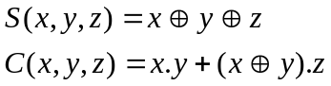

Implement the Full-Adder circuit by using the multiplexer 4539. Confirm that your multiplexer implementation is satisfying the truth table of Full-Adder.

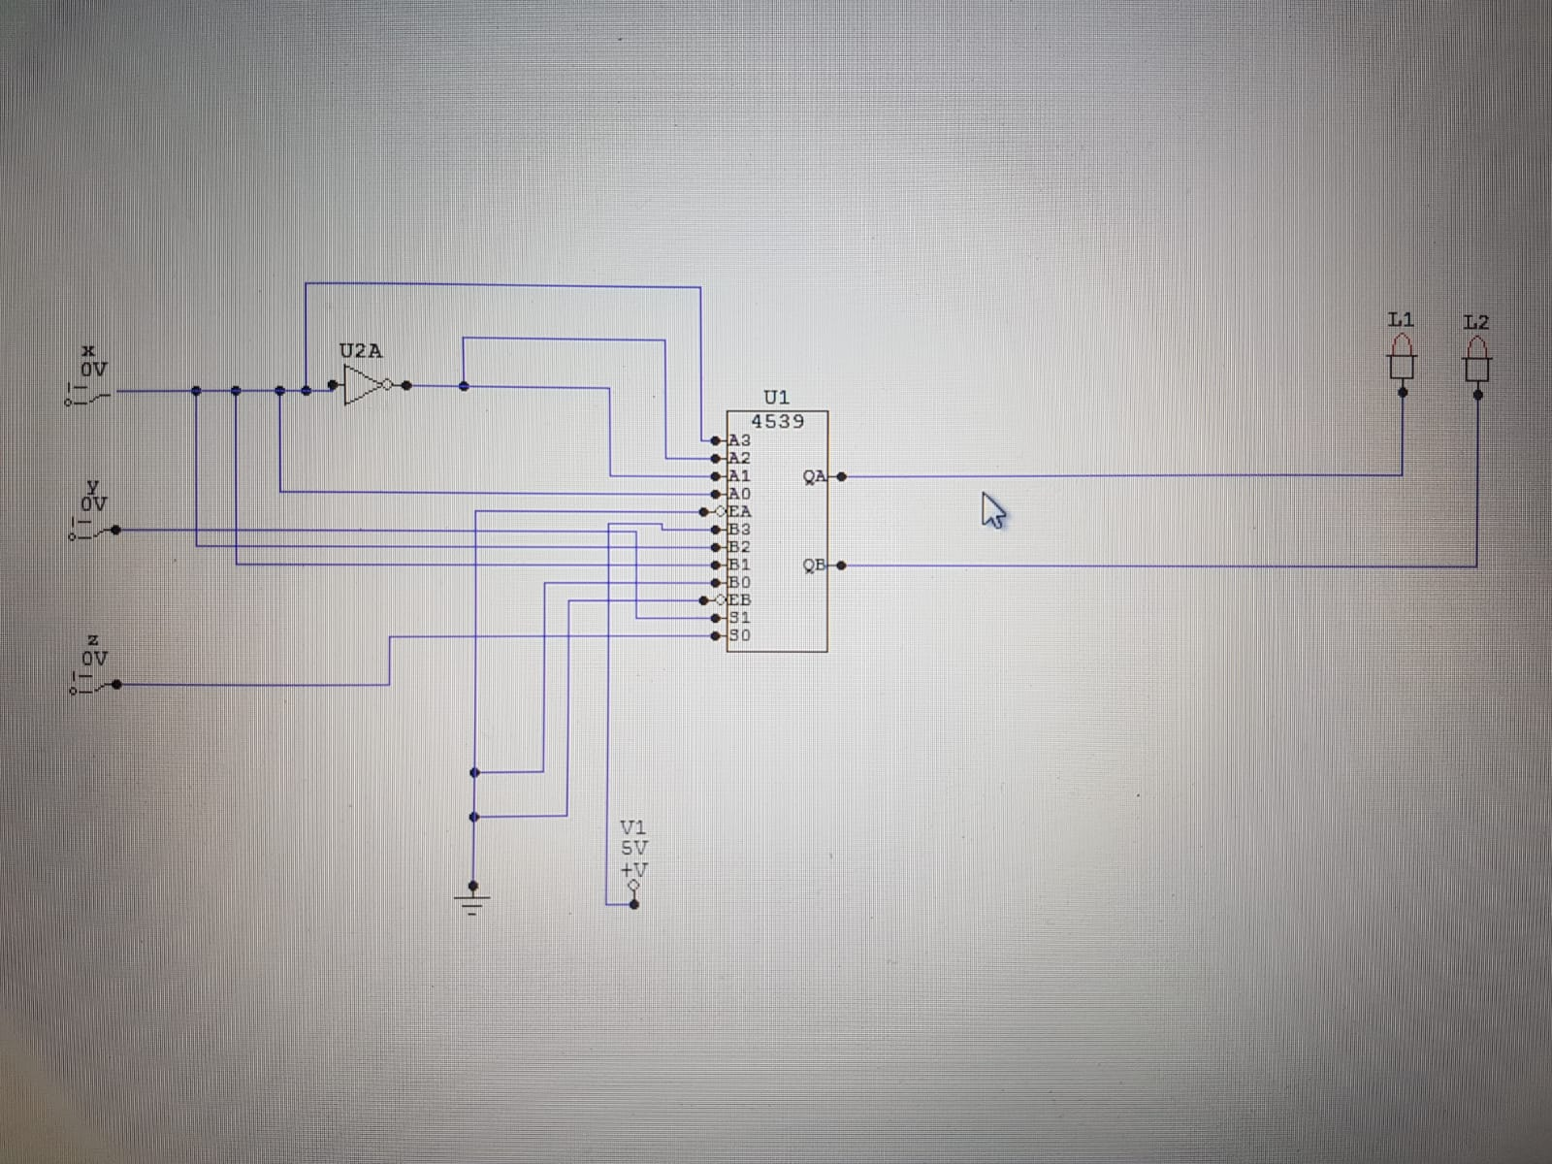

Multiplexer

X | Y | Z | C S
0 | 0 | 0 | 0 | 0
0 | 0 | 1 | 0 | 1
0 | 1 | 0 | 0 | 1
0 | 1 | 1 | 1 | 0
1 | 0 | 0 | 0 | 1
1 | 0 | 1 | 1 | 0
1 | 1 | 0 | 1 | 0
1 | 1 | 1 | 1 | 1

